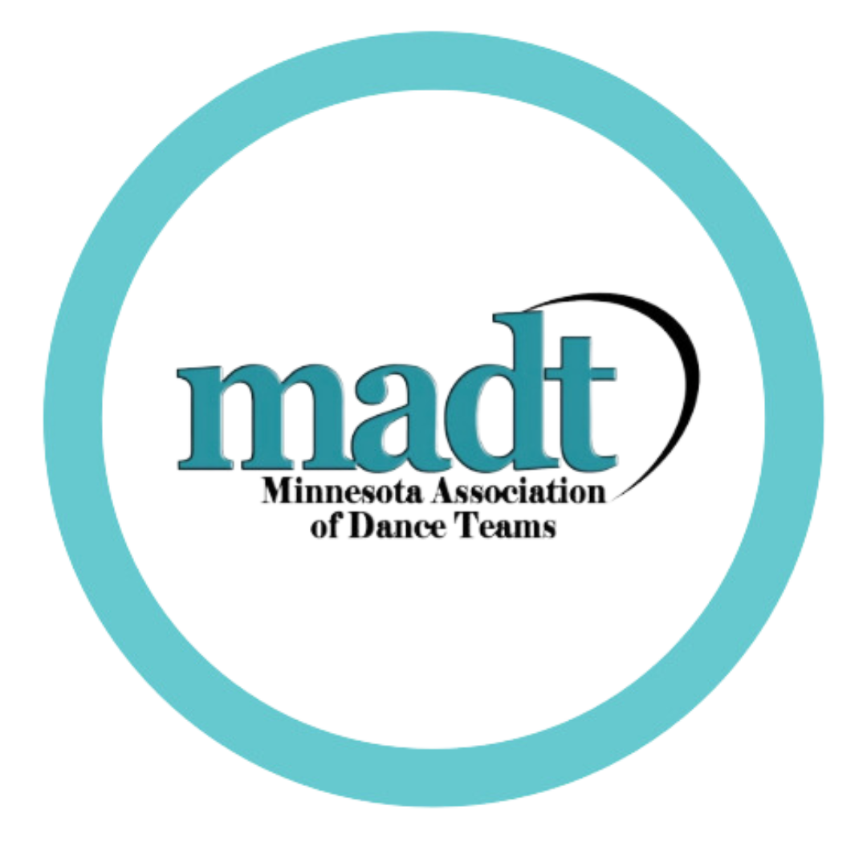
MINNESOTA ASSOCIATION OF DANCE TEAMS

BOARD OF DIRECTORS MEETING
WEDNESDAY, AUGUST 20th 2025 - SPRING LAKE PARK HIGH SCHOOL 6:00-9:00 PM
ATTENDEES: Kristen Gagnon, Tiffany Sandhurst, Michelle Kamenov, Brittany Rehling, Jenny Whiteley, Marissa Haakonon, Bridget Karnick, Janna Fitzgerald, Rea Ryan, Kayla Olson, Chelsea Lockrem, Bailey Stark

AGENDA
Call to order: 6:14pm

Secretary’s Report
- Review & approve minutes from Retreat
- Motion to approve: Rehling, Lockrem - Motion passed at 6:15pm

Treasurer’s Report
- Review & approve
- Motion to approve treasurer’s report: Whiteley, Karnick - motion passed at 6:16pm
- Balance & outstanding payments
  - Starting Balance = $33,915.50
  - Ending Balance = $30,614.95

Old Business
- Passwords / E-mails / Google Drive Access
  - Does anyone still need access to anything they don’t yet have?
  - Bailey needs access - help after meeting
- Action Items
  - Kristen still working to finalize new storage facility location
  - NDCA - Deadline September 22nd
    - (ACTION) - Everyone add to this document if you haven’t already
  - (ACTION) - Kayla to make social media post for teams to submit videos for JAM
- Info Meeting Recap
  - In attendance: 73 participants
  - Meeting Recap AI
- Membership Update
  - Current registrations so far
    - As of 8/17 - Total 83
      - All Inclusive 51
      - Regular 32
  - Facebook clean-up complete - Janna will add new members each Sunday
  - Levels of Membership (Associate, Regular, All-Inclusive)
    - Do we expand to Middle School, Fall, College, etc.?
    - Idea is to create an Associate membership
      - Non-voting
      - Fall only coaches
      - Former coaches
      - Hall of Fame - non active
      - Collegiate
      - Cannot vote on awards ballots
    - Motion to approve expanding membership to include an Associate level membership that is non-voting: Lockrem, Ryan
    - Motion carried at 6:46pm
    - (ACTION) - Janna to revise the membership form
  - BOD Registration
- All-State - Location still TBD, have not heard back from Two Rivers
  - March 7th is ideal date per Just For Kix
  - (ACTION) - Rea to reach out to schools for a all State Location
- MADT Reorganization
  - Board of Directors / Roles & Positions
  - SURVEY FEEDBACK
    - (ACTION) - Michelle to prioritize topics for discussion at BOD meetings throughout the upcoming year
  - ORG CHARTS
- Hall of Fame
  - Lifetime membership discussion
  - Updated Form - November 1st deadline - post to web & social
- Social Media
  - Posting Calendar/Timeline

New Business

Mentorship
- First Zoom Sunday, August 18th
  - Recap of how it went

Student Convention
- Check in on event - what help is needed
  - Reach out to Volunteers now
  - Get schedule set & delegate tasks & timelines
  - Printing materials, schedules, navigation/maps, QR codes to scan, etc.
  - List of instructors/bios/ headshots to market for registration
  - Solo Showcase
  - (ACTION) - get registration ready - goal is end of the week
  - Discussed needing more volunteers for the day - specifically the showcase & if we want to offer spectators

Fall Membership Meeting Prep
- MADT apparel
  - Who needs a name badge?
  - Does BOD want MADT branded apparel since we’re not doing a store this year?
  - (ACTION) - ALL BOD send Brittany sizes for sweatshirt, t-shirt & info for name badge if you do not have one
- Plan out timeline & what we are presenting/discussing SLIDES
  - (ACTION) - All BOD go into Fall Membership Meeting slides and add by Sunday Sept 7th

Budgeting - HISTORICAL DATA
- Budget Numbers for Events & Goals
    - Board MADT/MSCHA Membership
      - Table discussion on Assistant Coach membership options…. How to increase membership of assistant coaches
      - 2024-25: 306 members
      - 2024-25 Income from membership dues: $29,195
      - Estimated operating Costs: $18,000
      - Discussed goal for membership dues: $30,000
    - Board Meals
    - Student Convention
      - Discussed budget of: $3,000
    - Fall Membership Meeting
    - All-State Review
    - All-State
    - Spring Membership Meeting
    - Coaches Continuing Education
    - Coaches Celebration
    - NDCA
- (ACTION) - Brittany to enter numbers from 2024-25
- (ACTION) - Executive board to discuss budget Sept. 10th prior to Sept. 15th BOD Meeting
- (ACTION) -All Board responsible for adding or editing the - Master Vendor/Sponsor List - if they have talked to a sponsor or have a contact.

Motion to end meeting: Fitzgerald, Gagnon
Next Board Meeting: Monday September 15th 6-9pm @ Chanhassen

