
MINNESOTA ASSOCIATION OF DANCE TEAMS

BOARD OF DIRECTORS MEETING
MONDAY, SEPTEMBER 15TH - CHANHASSEN HIGH SCHOOL 6:00-9:00 PM
ATTENDEES: Board of Directors: Kristen Gagnon, Tiffany Sandhurst, Michelle Kamenov, Brittany Rehling, Jenny Whiteley, Marissa Haakonon, Bridget Karnick, Janna Fitzgerald, Rea Ryan, Kayla Olson, Chelsea Lockrem, Bailey Stark
Activity Advisory: Marit Green, Katie Ohlund, Rachel Doran, Nadia Fischer-Danzeisen, Rachel Norwood, Jamie Swenning
AGENDA
Call to order: 6:13pm

Secretary’s Report
- Review & approve minutes from August Meeting
- Motion to approve: Gagnon, Rehling - Motion carried at 6:15pm

New Business
- JAM Meeting Recap & Needs
  - JAM Meeting - Key Updates
    - Video Collection - low participation
    - Choreography Description Document
    - JAM Trainings: Invited to attend choreography training from 1:30-2:45pm
      - Saturday, October 4th, St. Cloud Cathedral
        - Same day as Fall Membership Meeting & Student Convention. Marissa will attend.
      - Saturday, October 25th, Edina Community Center
        - Majority of BOD & AA will plan to attend this day
    - JAM looking for input or ideas on scheduling meets - discussion on what would be helpful.
      - Subgroup of people - meet and discuss different things that could benefit coaches in a scheduling process
      - Limiting the number of competitors to 12-14

- MSHSL League Activity Advisory Meeting - Friday, September 19th
  - Agenda Item:
    - Proposal
      - How are things going without tryouts? How are teams doing?
    - Zero Week
    - Procedural Manual: Having something posted on the league website as a resource for teams hosting invites
    - FAQs - what to edit / add
    - State Tournament - dressing spaces concerns
    - State Tournament - warm up spaces and opportunities
    - State Tournament - spectator seating:
      - People vacating during the competition leaving empty sections while teams are competing.
      - Can they allow Class A fans to sit on AAA side during Class A competition even though they are “reserved” for AAA? Last year they were sent away because of security.

Fall Membership Meeting - October 4th
- Agenda for Fall Membership Meeting
  - SLIDES
  - Layout/Format, Speakers, Breakout Group Leads
    - Registration at 8:30 - BOD will split up with some people at Student registration
    - 9am-12pm
  - What to wear: Apparel & Badges
  - Report out on AA meeting with the league

Student Convention - October 4th
- Only 70 dancers registered - how can we encourage/engage more this week?
  - Solo Showcase Participants: 15
- Schedule of the day/timelines
  - Printing materials, schedules, navigation/maps, QR codes to scan, etc.
  - Solo Showcase schedule
- What help is still needed?
- Look at 2026 Dates (Summer? Early Fall?)
  - Suggestions: Second week of August (after UDA Camp, before Fall starts)

Old Business

Treasurer’s Report
- Review & approve
  - Motion to approve: Whiteley, Karnick - motion carried at 8:28pm
- Balance & outstanding payments
- Sponsorships/Partnerships: Master Vendor/Sponsor List - Event leads coordinate with Brittany
- (ACTION) - Jenny & Brittany to create a budget template

Action Items
- Review Outstanding Action Items (ACTION) - Everyone review Action Items! Edit if completed.
  - New Storage Facility Location - $29/month
  - NDCA Textbook Project - Deadline September 22nd
  - Levels of Membership (Associate, Regular, All-Inclusive)
    - BOD Motion passed to Expand to Middle School, Fall, College, Former Coach which creates the need for a By-Law Change
      - Associate membership
        - Non-voting on proposals or for awards ballots
        - Fall only coaches (if also a winter coach, register as winter)
        - Former coaches
        - Hall of Fame - non-active coach
        - Collegiate
    - Janna revised the membership form

- Membership Update
  - Current registrations as of 9/14 - Total 136
      - All Inclusive 82
      - Regular 54

- Mentorship next Zoom Sunday, September 21st @7pm
  - Try-out prep, formations, team culture, goal setting, etc.
  - (ACTION) - Look at mentorship dates to see what zooms you can attend

- All-State - Location still TBD, AV March 7th / EP March 14th
  - March 7th is ideal date per Just For Kix

- Coaches Celebration/CCE/Spring Membership Meeting - any updates?
  - Coaches Celebration venue proposal: Warehouse Winery (6415 Cambridge St, Minneapolis, MN 55416)
    - Change in layout proposed: Heavier hors d'oeuvres / food stations with other “activities” going on to create a more social atmosphere. We would pause for the program of awards, etc.
    - I think we can keep cost similar to last year’s celebration
  - Motion to approve CC expenses for Venue: Sandhurst, Fitzgerald - motion carried at 9:02pm
  - (ACTION) - Kristen to follow up with Warehouse Winery and booking space for Friday
  - Motion to approve James Silvas for CCE Keynote Speaker - Haakonson, Lockrem - Motion carried at 9:07pm
  - (ACTION) - Rea to have follow up call with James Silvas to finalize details and proceed with booking

- MADT Reorganization
  - Board of Directors / Roles & Positions
  - SURVEY FEEDBACK
    - Prioritization topics-Decisions-Timeline-By-Law Update
    - Begin discussion/review of options-priorization: Class Representation on BOD.docx
    - (ACTION) - All BOD to review these scenarios and provide feedback via comments
  - ORG CHARTS

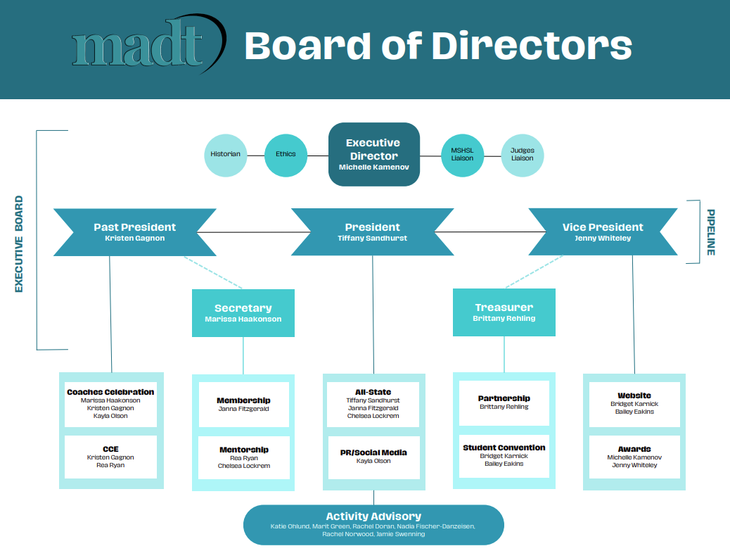

- Hall of Fame
  - Lifetime membership discussion
  - Updated Form - November 1st deadline

Motion to adjourn the meeting: Rehling, Gagnon - motion carried 9:32pm

Upcoming Meetings:
Wednesday, October 1st: 7:00 PM Google Meet - Pipeline
Wednesday, October 15th: 7:00 PM Google Meet - Executive Board
Sunday, November 9th: 6:00-8:00 PM - Zoom - BOD & Activity Advisory

